 | SPECIFICATION SHEET  Approved Ideal Lux dealer

IDEAL LUX · ACQUA COLLECTION · OUTDOOR LIGHTING
Acqua PT1
Turned aluminum reflecting body with matt paint, available finishes: anthracite or coffee. Tempered glass diffuser.
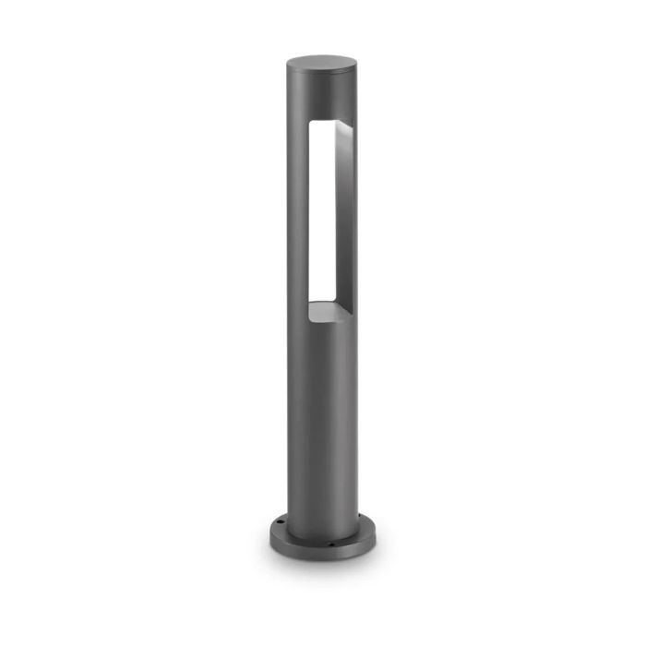 | 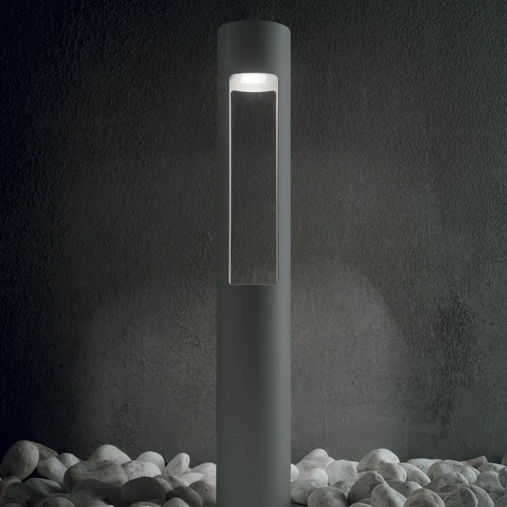

Specification
Dimensions | Ø 135 × H 600 mm
Lamp holder / power | G9 max 1 × 15W
IP rating | IP44 (outdoor rated)
Bulb included | No, sold separately
Recommended bulb | 307879 G9 4.0W 4000K Cri80
Dimming | Non-dimmable
Insulation class | I
Operating temperature | 0° ~ +40 °C
Warranty | 5 years
Net weight | 1.5 kg
EAN | 8021696135205
Product code | 135205

UK retail price: £160.00 ex VAT · £192.00 inc VAT
Trade, project and quantity pricing on request. Delivery and lead time confirmed at order.
Specification from the Ideal Lux technical sheet rev. 21-07-2026, checked 2026-10-01. Manufacturer data may change; confirm before ordering. Images © Ideal Lux.

