 | SPECIFICATION SHEET  Approved Ideal Lux dealer

IDEAL LUX · AGOS COLLECTION · OUTDOOR LIGHTING
Agos PT H60 3000K Black
Powder coated die-cast aluminum body. Satin clear acrylic diffuser. Anthracite, coffee or black color.
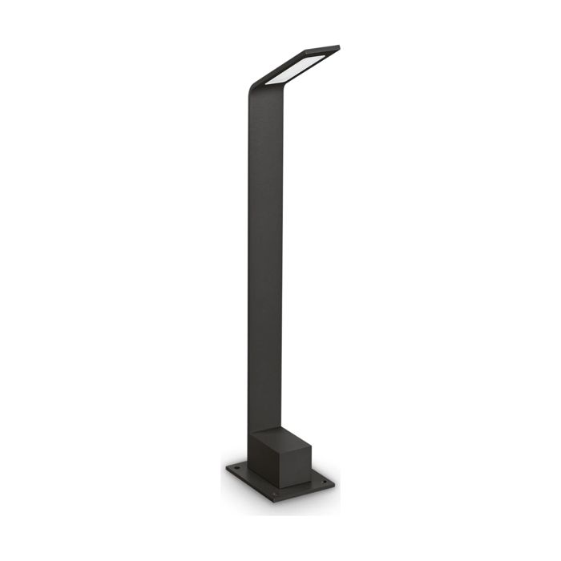 | 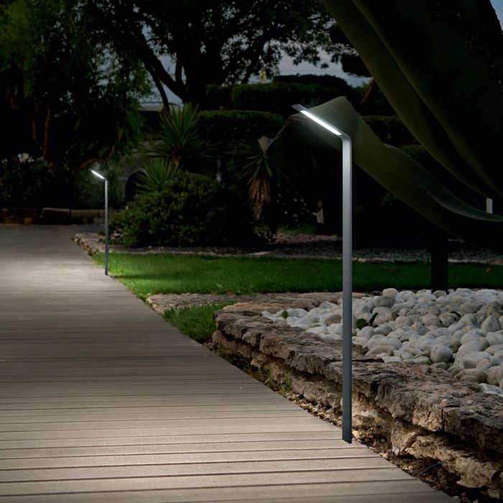

Specification
Dimensions | L 95 × H 600 × D 150 mm (L length, H height, D depth)
Specification | 6,5W
LED lifetime | 25000 hours
Colour temperature | 3000 K
Light output (LED source) | 670 lumen
IP rating | IP54 (outdoor rated)
Bulb included | Integrated LED
Colour rendering (CRI) | > 90
Light output (from fitting) | 560 lm
Beam angle | 120*70°
Dimming | Non-dimmable, On-Off
Insulation class | I
Operating temperature | -15° ~ +45 °C
Warranty | 5 years
Net weight | 0.95 kg
EAN | 8021696326696
Product code | 326696

UK retail price: £81.00 ex VAT · £97.20 inc VAT
Trade, project and quantity pricing on request. Delivery and lead time confirmed at order.
Specification from the Ideal Lux technical sheet rev. 21-07-2026, checked 2026-10-02. Manufacturer data may change; confirm before ordering. Images © Ideal Lux.

