 | SPECIFICATION SHEET  Approved Ideal Lux dealer

IDEAL LUX · AMADEUS COLLECTION · CHANDELIERS · INDOOR
Amadeus SP6
Metal chrome frame. Decorative elements made of blown glass and cut crystals. Velvet chain cover.
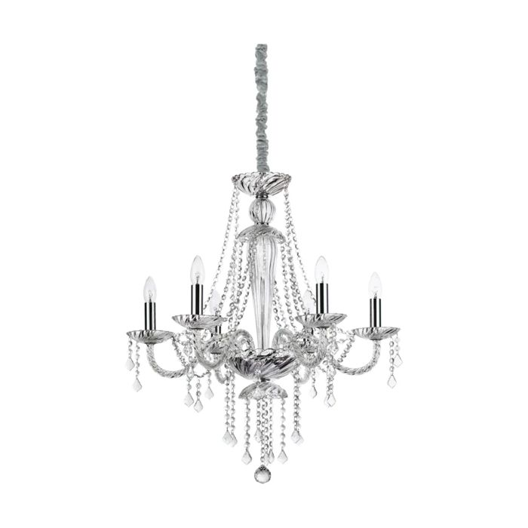 | 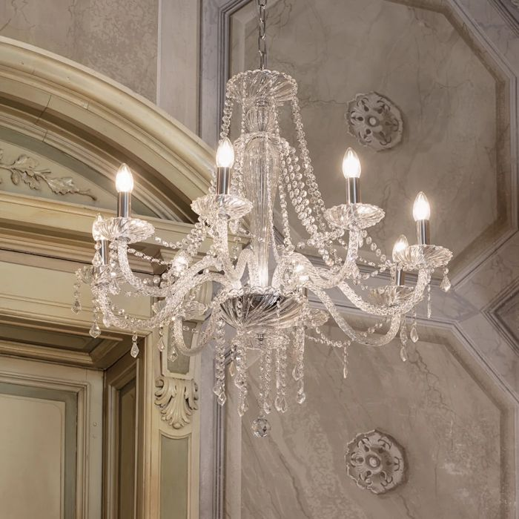

Specification
Dimensions | Ø 670 × H min 790 / max 1500 mm
Lamp holder / power | E14 max 6 × 40W
IP rating | IP20 (indoor)
Bulb included | No, sold separately
Recommended bulb | 101224 E14 Oliva 4W 3000K Cri80 Trasp
Dimming | Non-dimmable
Insulation class | I
Operating temperature | 0° ~ +40 °C
Warranty | 5 years
Net weight | 6.7 kg
EAN | 8021696168753
Product code | 168753

UK retail price: £480.00 ex VAT · £576.00 inc VAT
Trade, project and quantity pricing on request. Delivery and lead time confirmed at order.
Specification from the Ideal Lux technical sheet rev. 21-07-2026, checked 2026-10-01. Manufacturer data may change; confirm before ordering. Images © Ideal Lux.

