 | SPECIFICATION SHEET  Approved Ideal Lux dealer

IDEAL LUX · AMPOLLA COLLECTION · PENDANTS · INDOOR
Ampolla-3 SP1 Black
Metal ceiling rose, bulb socket and decorative structure with white or black finishes. Power cable adjustable in length.
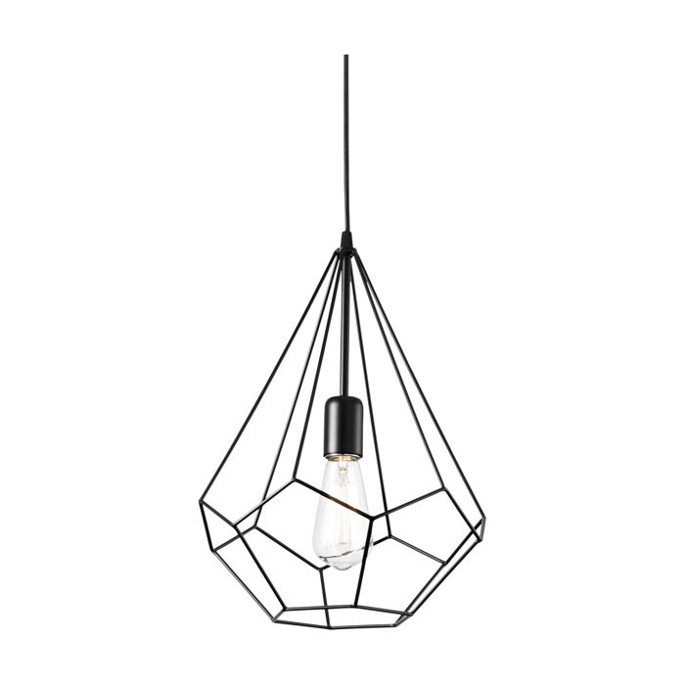 | 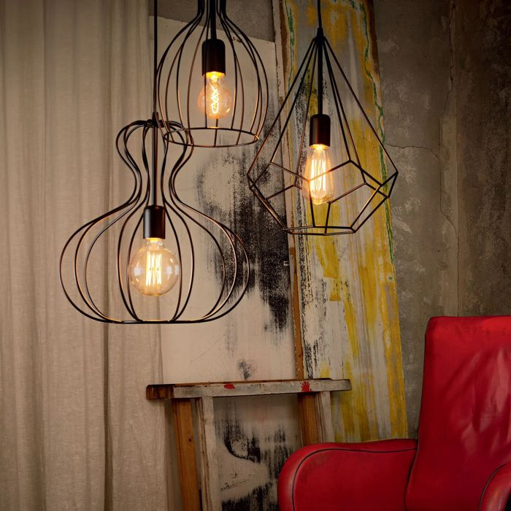

Specification
Dimensions | Ø 300 × H min 670 / max 1200 mm
Lamp holder / power | E27 max 1 × 60W
IP rating | IP20 (indoor)
Bulb included | No, sold separately
Recommended bulb | 151694 E27 Cono 4W 2200K Cri80 Ambra
Dimming | Non-dimmable
Insulation class | II
Operating temperature | 0° ~ +40 °C
Warranty | 5 years
Net weight | 0.72 kg
EAN | 8021696148175
Product code | 148175

UK retail price: £222.00 ex VAT · £266.40 inc VAT
Trade, project and quantity pricing on request. Delivery and lead time confirmed at order.
Specification from the Ideal Lux technical sheet rev. 21-07-2026, checked 2026-10-02. Manufacturer data may change; confirm before ordering. Images © Ideal Lux.

