 | SPECIFICATION SHEET  Approved Ideal Lux dealer

IDEAL LUX · AMPOLLA COLLECTION · PENDANTS · INDOOR
Ampolla-4 SP1 Black
Metal ceiling rose, bulb socket and decorative structure with white or black finishes. Power cable adjustable in length.
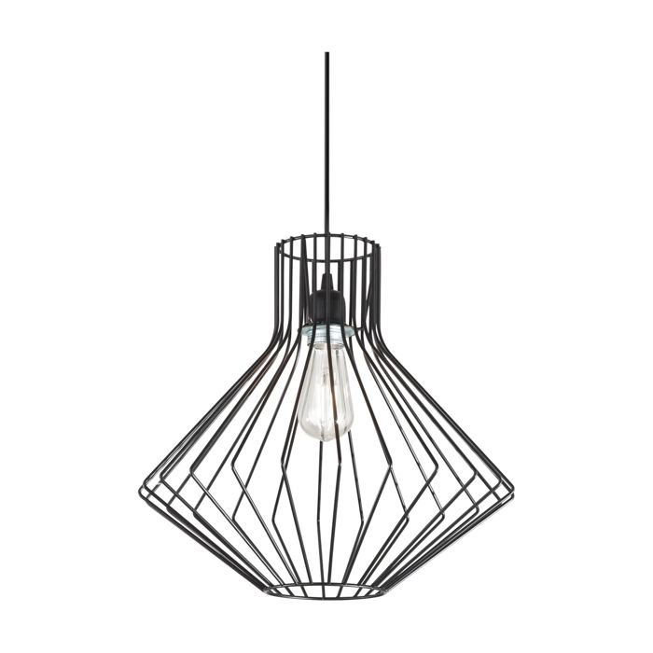 | 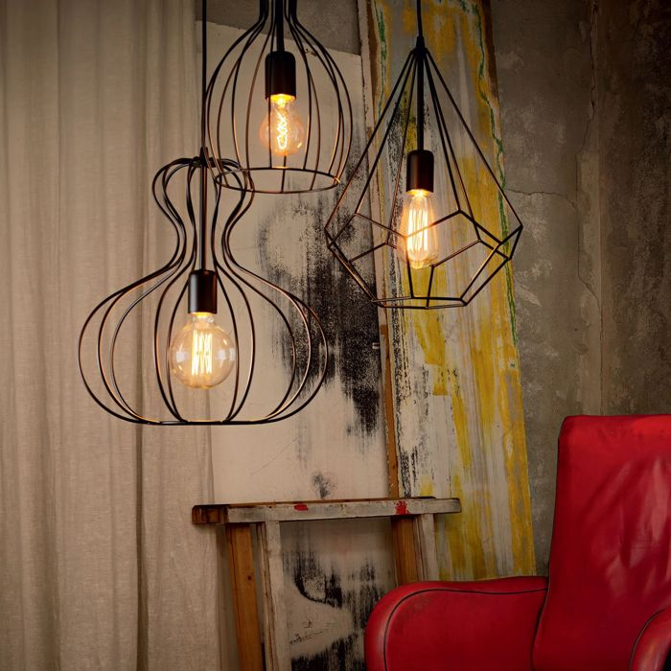

Specification
Dimensions | Ø 395 × H min 620 / max 1430 mm
Lamp holder / power | E27 max 1 × 60W
IP rating | IP20 (indoor)
Bulb included | No, sold separately
Recommended bulb | 151694 E27 Cono 4W 2200K Cri80 Ambra
Dimming | Non-dimmable
Insulation class | II
Operating temperature | 0° ~ +40 °C
Warranty | 5 years
Net weight | 1.47 kg
EAN | 8021696167497
Product code | 167497

UK retail price: £240.00 ex VAT · £288.00 inc VAT
Trade, project and quantity pricing on request. Delivery and lead time confirmed at order.
Specification from the Ideal Lux technical sheet rev. 21-07-2026, checked 2026-10-02. Manufacturer data may change; confirm before ordering. Images © Ideal Lux.

