 | SPECIFICATION SHEET  Approved Ideal Lux dealer

IDEAL LUX · ANDROMEDA COLLECTION · OUTDOOR LIGHTING
Andromeda AP1
Die-cast aluminum body light with varnish finish. Double frosted Pyrex glass, up-and-down. Available finishes: anthracite, white, coffee, grey or black.
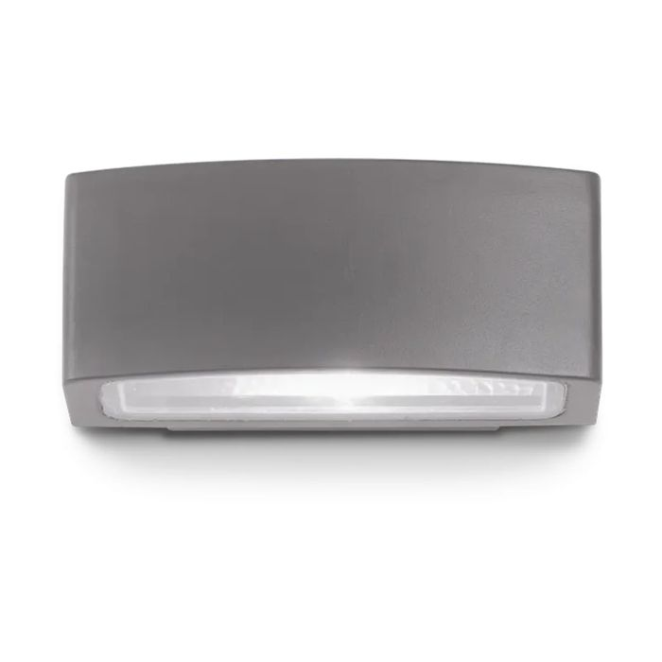 | 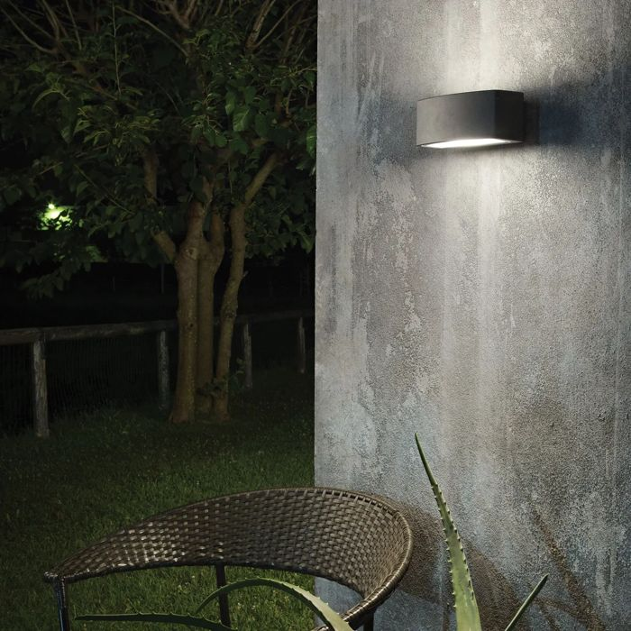

Specification
Dimensions | L 220 × H 90 × D 120 mm (L length, H height, D depth)
Lamp holder / power | E27 max 1 × 60W
IP rating | IP55 (outdoor rated)
Bulb included | No, sold separately
Recommended bulb | 151960 E27 Sfera 6W 4000K Cri80 Bianco
Dimming | Non-dimmable
Insulation class | I
Operating temperature | -15° ~ +45 °C
Warranty | 5 years
Net weight | 1 kg
EAN | 8021696061580
Product code | 061580

UK retail price: £55.00 ex VAT · £66.00 inc VAT
Trade, project and quantity pricing on request. Delivery and lead time confirmed at order.
Specification from the Ideal Lux technical sheet rev. 23-07-2026, checked 2026-10-01. Manufacturer data may change; confirm before ordering. Images © Ideal Lux.

