 | SPECIFICATION SHEET  Approved Ideal Lux dealer

IDEAL LUX · ANGOLO COLLECTION · CEILING LIGHTS · INDOOR
Angolo PL3 Brass
Powder-coated or plated metal frame. White blown and acid-etched glass diffusers. Available finishes: black or satin brass.
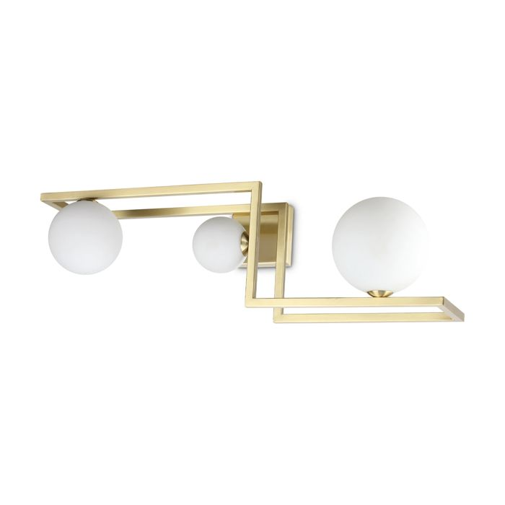 | 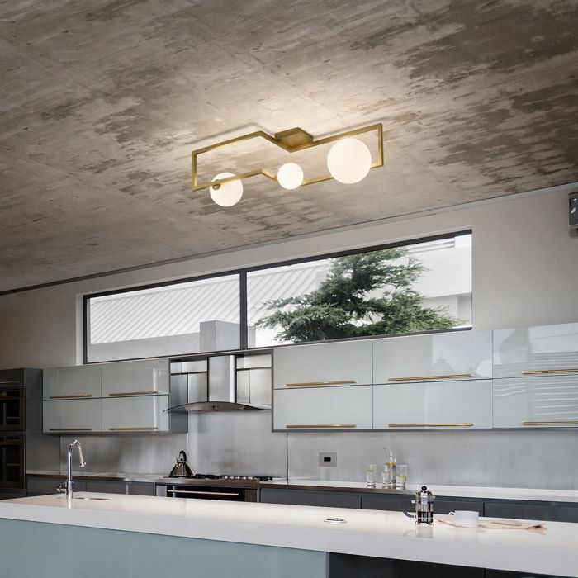

Specification
Dimensions | L 686 × H 250 × D 200 mm (L length, H height, D depth)
Lamp holder / power | G9 max 3 × 28W
IP rating | IP20 (indoor)
Bulb included | Yes
Dimming | Non-dimmable
Insulation class | II
Operating temperature | 0° ~ +40 °C
Warranty | 5 years
Net weight | 1.65 kg
EAN | 8021696284330
Product code | 284330

UK retail price: £185.00 ex VAT · £222.00 inc VAT
Trade, project and quantity pricing on request. Delivery and lead time confirmed at order.
Specification from the Ideal Lux technical sheet rev. 23-07-2026, checked 2026-10-02. Manufacturer data may change; confirm before ordering. Images © Ideal Lux.

