 | SPECIFICATION SHEET  Approved Ideal Lux dealer

IDEAL LUX · ANGOLO COLLECTION · FLOOR LAMPS · INDOOR
Angolo PT5 Brass
Powder-coated or plated metal frame. White blown and acid-etched glass diffusers. Black PVC cable with switch and plug. Available finishes: black or satin brass.
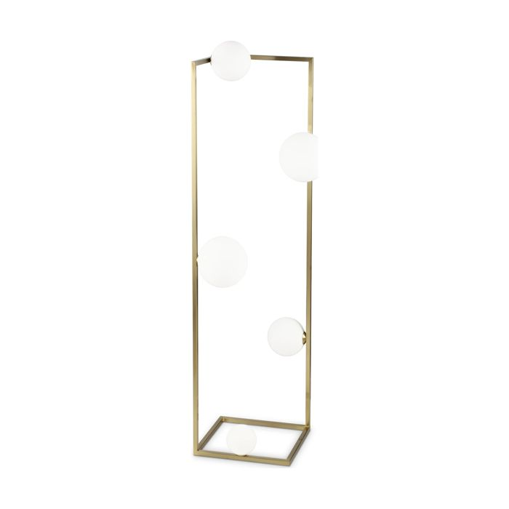 | 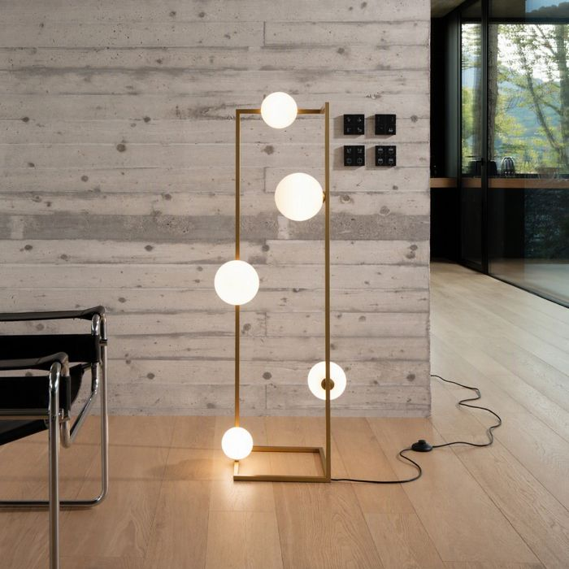

Specification
Dimensions | L 300 × H 1180 × D 300 mm (L length, H height, D depth)
Lamp holder / power | G9 max 5 × 28W
IP rating | IP20 (indoor)
Bulb included | Yes
Dimming | Non-dimmable
Insulation class | II
Operating temperature | 0° ~ +40 °C
Warranty | 5 years
Net weight | 2.7 kg
EAN | 8021696284354
Product code | 284354

UK retail price: £280.00 ex VAT · £336.00 inc VAT
Trade, project and quantity pricing on request. Delivery and lead time confirmed at order.
Specification from the Ideal Lux technical sheet rev. 21-07-2026, checked 2026-10-02. Manufacturer data may change; confirm before ordering. Images © Ideal Lux.

