 | SPECIFICATION SHEET  Approved Ideal Lux dealer

IDEAL LUX · ARCADIA COLLECTION · OUTDOOR LIGHTING
Arcadia PT1 White
Powder coated metal base and stem. PMMA white diffuser. Neoprene cable with plug. Finish: white, anthracite.
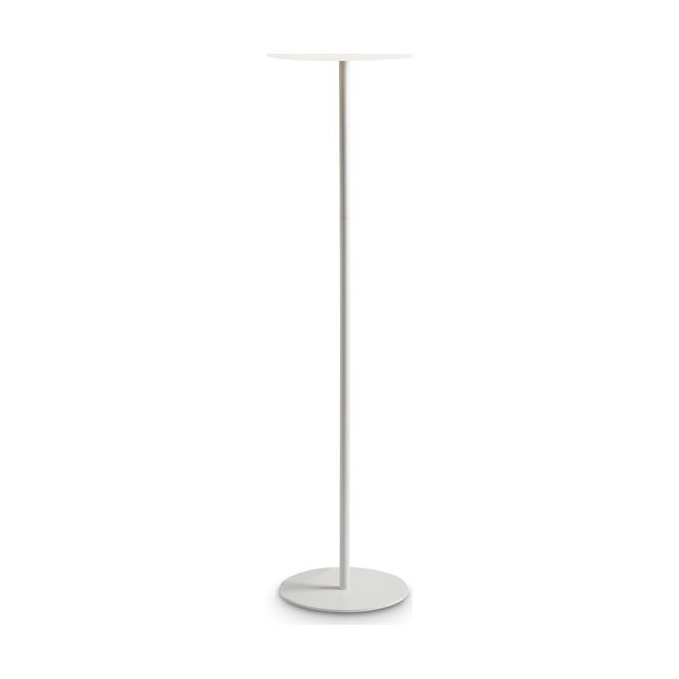 | 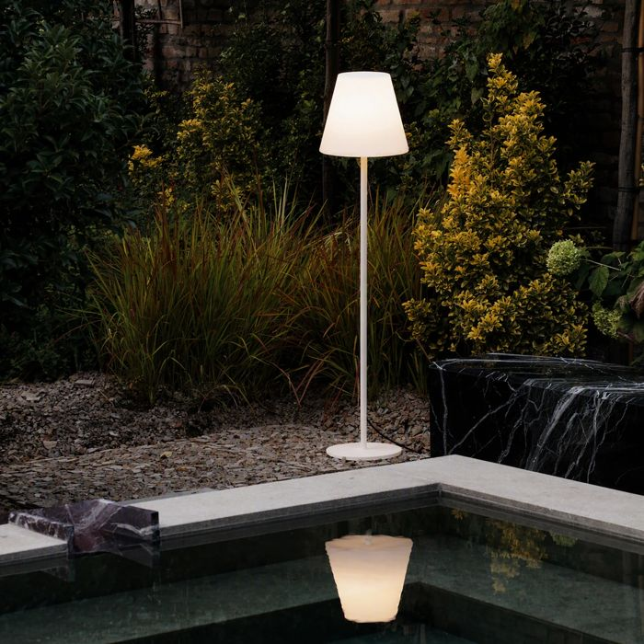

Specification
Dimensions | Ø 347 × H 1536 mm
Lamp holder / power | E27 max 1 × 42W
IP rating | IP44 (outdoor rated)
Bulb included | No, sold separately
Recommended bulb | 151991 E27 Goccia 09W 4000K Cri80 Bianco
Dimming | Non-dimmable
Insulation class | II
Operating temperature | -15° ~ +45 °C
Warranty | 5 years
Net weight | 6.5 kg
EAN | 8021696365749
Product code | 365749

UK retail price: £152.00 ex VAT · £182.40 inc VAT
Trade, project and quantity pricing on request. Delivery and lead time confirmed at order.
Specification from the Ideal Lux technical sheet rev. 24-07-2026, checked 2026-10-02. Manufacturer data may change; confirm before ordering. Images © Ideal Lux.

