 | SPECIFICATION SHEET  Approved Ideal Lux dealer

IDEAL LUX · ARCHIMEDE COLLECTION · PENDANTS · INDOOR
Archimede SP Cono Black
Powder coated metal ceiling cap with magnetic closure without screws. PVC cable. Powder coated aluminum diffuser with acrylic optic. Finishes: white, black.
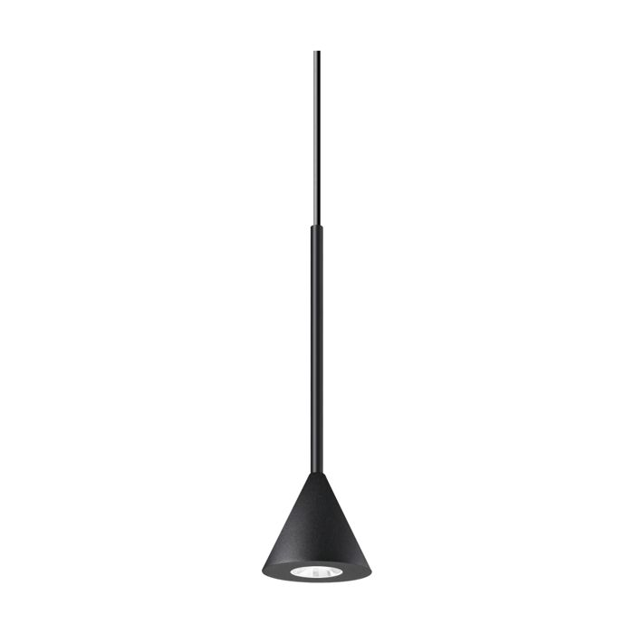 | 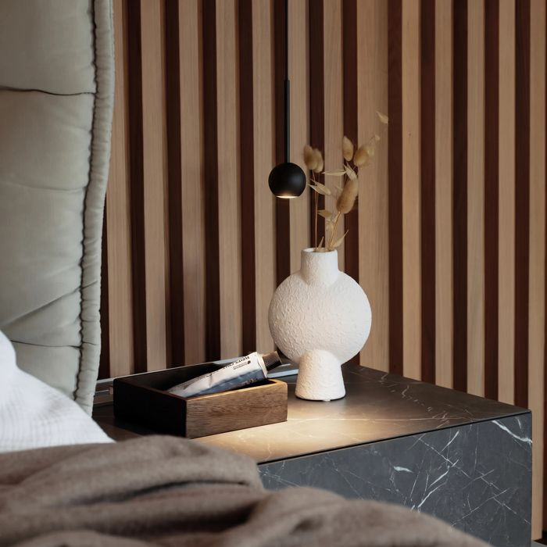

Specification
Dimensions | Ø 90 × H min 375 / max 6150 mm
Light source | LED 4W
LED lifetime | 50000 hours
Colour temperature | 3000 K
Light output (LED source) | 250 lumen
IP rating | IP20 (indoor)
Bulb included | Integrated LED
Colour rendering (CRI) | > 90
Light output (from fitting) | 210 lm
Beam angle | 24°
Dimming | Non-dimmable, On-Off
Insulation class | II
Operating temperature | 0° ~ +40 °C
Warranty | 5 years
Net weight | 0.14 kg
EAN | 8021696328348
Product code | 328348

UK retail price: £70.00 ex VAT · £84.00 inc VAT
Trade, project and quantity pricing on request. Delivery and lead time confirmed at order.
Specification from the Ideal Lux technical sheet rev. 22-07-2026, checked 2026-10-02. Manufacturer data may change; confirm before ordering. Images © Ideal Lux.

