 | SPECIFICATION SHEET  Approved Ideal Lux dealer

IDEAL LUX · ARGO COLLECTION · OUTDOOR LIGHTING
Argo AP2 4000K
Powder coated die-cast aluminum body. Clear tempered glass diffuser with white inner reflector. Available in anthracite or white finish.
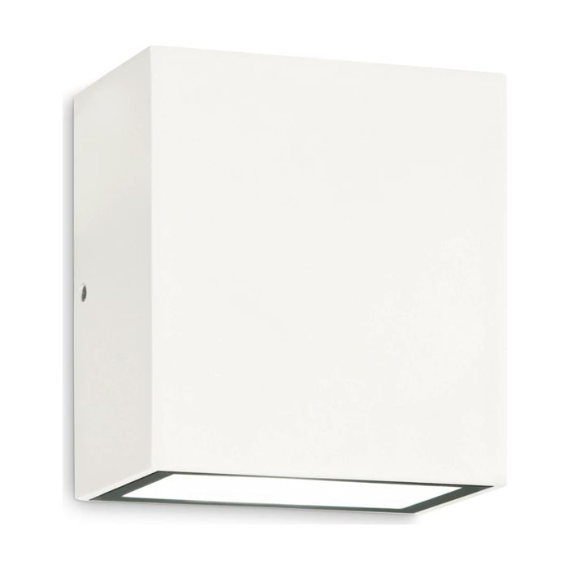 | 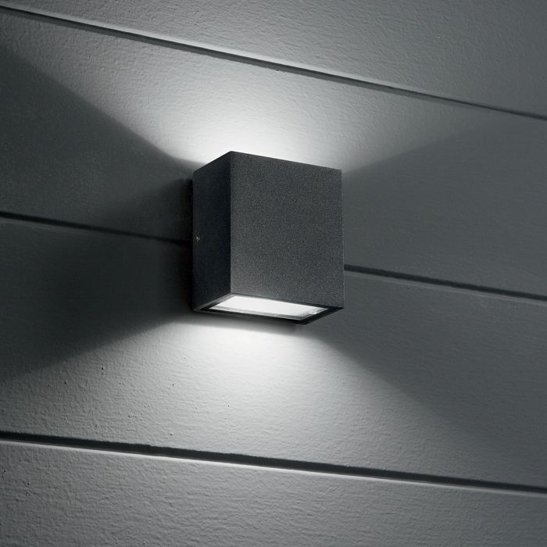

Specification
Dimensions | L 90 × H 100 × D 55 mm (L length, H height, D depth)
Light source | Integrated LED 11W
LED lifetime | 30000 hours
Colour temperature | 4000 K
Light output (LED source) | 1150 lumen
IP rating | IP65 (outdoor rated)
Bulb included | Integrated LED
Colour rendering (CRI) | > 90
Light output (from fitting) | 980 lm
Beam angle | 85+85°
Dimming | Non-dimmable, On-Off
Insulation class | I
Operating temperature | -15° ~ +45 °C
Warranty | 5 years
Net weight | 0.6 kg
EAN | 8021696268316
Product code | 268316

UK retail price: £81.00 ex VAT · £97.20 inc VAT
Trade, project and quantity pricing on request. Delivery and lead time confirmed at order.
Specification from the Ideal Lux technical sheet rev. 23-07-2026, checked 2026-10-02. Manufacturer data may change; confirm before ordering. Images © Ideal Lux.

