 | SPECIFICATION SHEET  Approved Ideal Lux dealer

IDEAL LUX · ARMONY COLLECTION · CEILING LIGHTS · INDOOR
Armony PL D60
Matt varnished metal frame. Hanging decorative elements in metal wire with transparent chromed glass beads. Finishes: white.
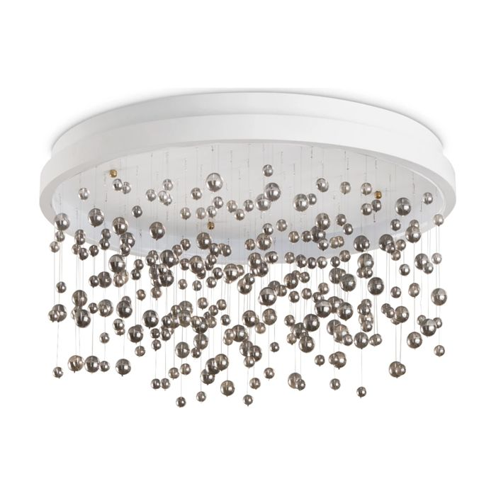 | 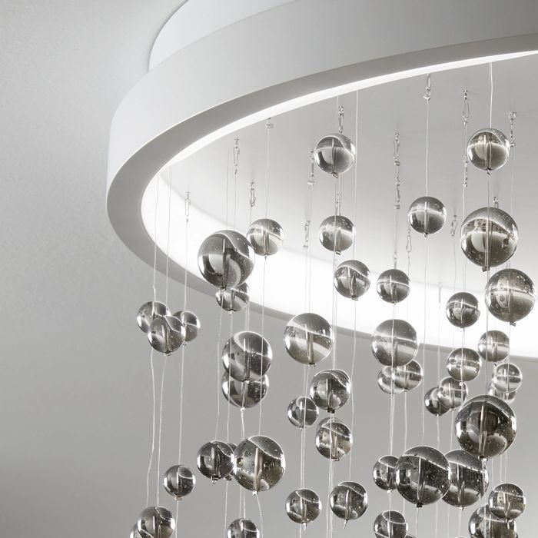

Specification
Dimensions | Ø 600 × H 320 mm
Light source | LED 56W
LED lifetime | 30000 hours
Colour temperature | 3000 K
Light output (LED source) | 5450 lumen
IP rating | IP20 (indoor)
Bulb included | Integrated LED
Colour rendering (CRI) | > 90
Light output (from fitting) | 2720 lm
Dimming | 1, TRIAC
Insulation class | II
Operating temperature | 0° ~ +40 °C
Warranty | 5 years
Net weight | 7.83 kg
EAN | 8021696315805
Product code | 315805

UK retail price: £450.00 ex VAT · £540.00 inc VAT
Trade, project and quantity pricing on request. Delivery and lead time confirmed at order.
Specification from the Ideal Lux technical sheet rev. 22-07-2026, checked 2026-10-02. Manufacturer data may change; confirm before ordering. Images © Ideal Lux.

