 | SPECIFICATION SHEET  Approved Ideal Lux dealer

IDEAL LUX · ARMONY COLLECTION · CEILING LIGHTS · INDOOR
Armony PL D75
Matt varnished metal frame. Hanging decorative elements in metal wire with transparent chromed glass beads. Finishes: white.
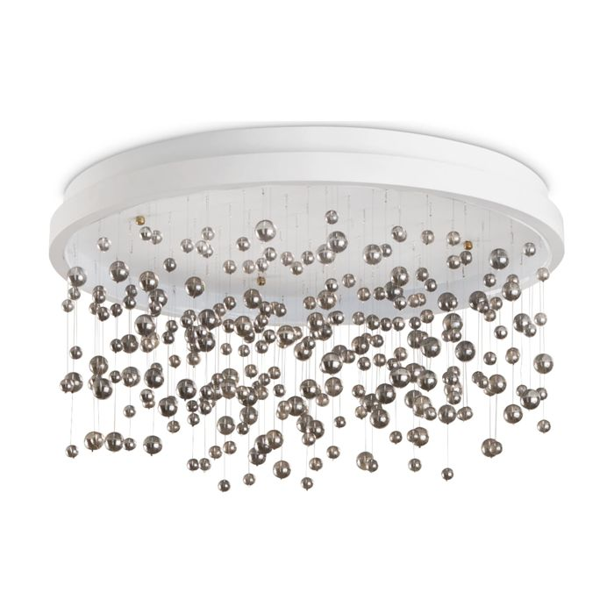 | 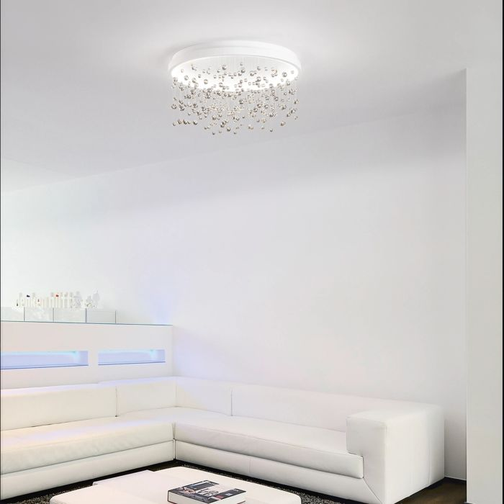

Specification
Dimensions | Ø 750 × H 320 mm
Light source | LED 70W
LED lifetime | 30000 hours
Colour temperature | 3000 K
Light output (LED source) | 6700 lumen
IP rating | IP20 (indoor)
Bulb included | Integrated LED
Colour rendering (CRI) | > 90
Light output (from fitting) | 3280 lm
Dimming | 1, TRIAC
Insulation class | II
Operating temperature | 0° ~ +40 °C
Warranty | 5 years
Net weight | 10.5 kg
EAN | 8021696315812
Product code | 315812

UK retail price: £600.00 ex VAT · £720.00 inc VAT
Trade, project and quantity pricing on request. Delivery and lead time confirmed at order.
Specification from the Ideal Lux technical sheet rev. 21-07-2026, checked 2026-10-02. Manufacturer data may change; confirm before ordering. Images © Ideal Lux.

