 | SPECIFICATION SHEET  Approved Ideal Lux dealer

IDEAL LUX · ATOM COLLECTION · OUTDOOR LIGHTING
Atom AP D10 3000K
Powder coated aluminum body. Glass diffusers. Double light beam, up and down with adjustable width and movable wings.
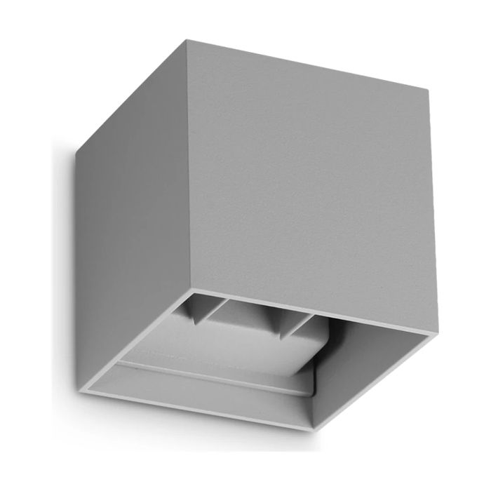 | 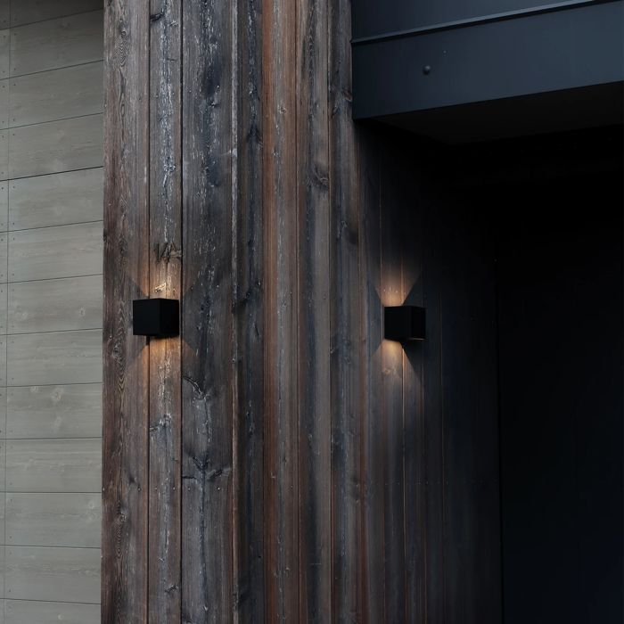

Specification
Dimensions | L 100 × H 100 × D 100 mm (L length, H height, D depth)
Light source | Integrated LED 12W
LED lifetime | 30000 hours
Colour temperature | 3000 K
Light output (LED source) | 1150 lumen
IP rating | IP54 (outdoor rated)
Bulb included | Integrated LED
Colour rendering (CRI) | > 90
Light output (from fitting) | 670 lm
Dimming | Non-dimmable, On-Off
Insulation class | I
Operating temperature | -15° ~ +45 °C
Warranty | 5 years
Net weight | 0.65 kg
EAN | 8021696366821
Product code | 366821

UK retail price: £71.00 ex VAT · £85.20 inc VAT
Trade, project and quantity pricing on request. Delivery and lead time confirmed at order.
Specification from the Ideal Lux technical sheet rev. 24-07-2026, checked 2026-10-02. Manufacturer data may change; confirm before ordering. Images © Ideal Lux.

