 | SPECIFICATION SHEET  Approved Ideal Lux dealer

IDEAL LUX · BRIGITTA COLLECTION · CHANDELIERS · INDOOR
Brigitta SP12
Handcrafted clear or amber blown glass chandelier with metal body and velvet chain cover.
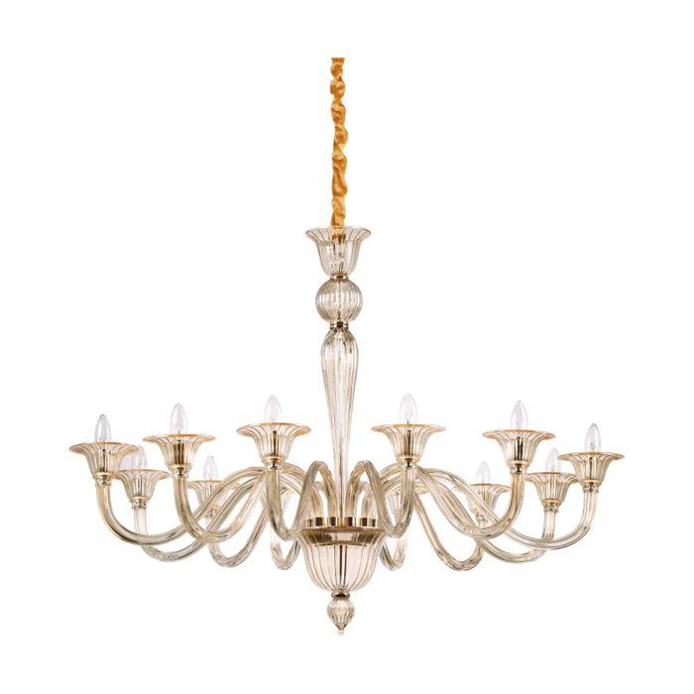 | 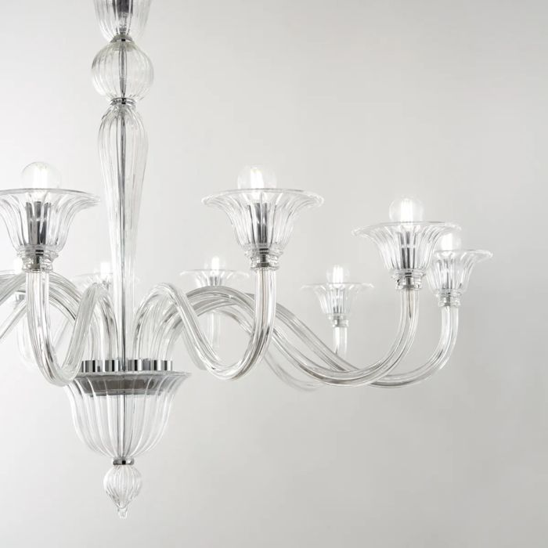

Specification
Dimensions | Ø 1200 × H min 1095 / max 1840 mm
Lamp holder / power | E14 max 12 × 40W
IP rating | IP20 (indoor)
Bulb included | No, sold separately
Recommended bulb | 101200 E14 Sfera 4W 3000K Cri80 Trasp
Dimming | Non-dimmable
Insulation class | I
Operating temperature | 0° ~ +40 °C
Warranty | 5 years
Net weight | 12.5 kg
EAN | 8021696199405
Product code | 199405

UK retail price: £1,000.00 ex VAT · £1,200.00 inc VAT
Trade, project and quantity pricing on request. Delivery and lead time confirmed at order.
Specification from the Ideal Lux technical sheet rev. 21-07-2026, checked 2026-10-01. Manufacturer data may change; confirm before ordering. Images © Ideal Lux.

