 | SPECIFICATION SHEET  Approved Ideal Lux dealer

IDEAL LUX · DAISY COLLECTION · CEILING LIGHTS · INDOOR
Daisy PL6
Metal base with gold leaf finish. White acid-etched blown glass diffusers with stripes in relief.
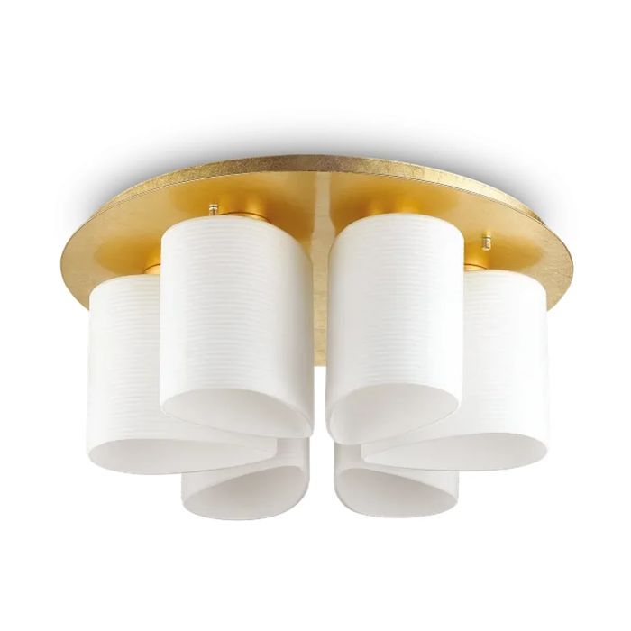 | 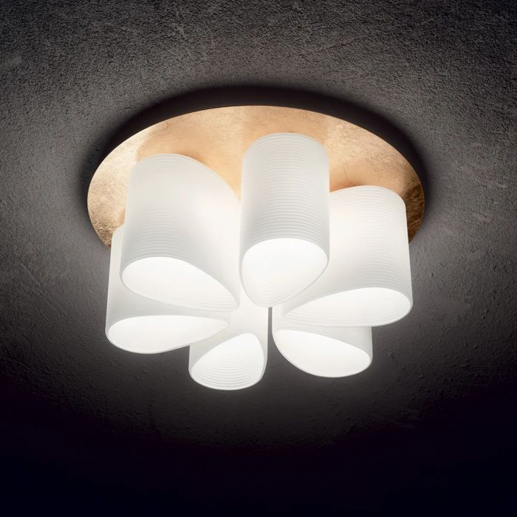

Specification
Dimensions | Ø 600 × H 255 mm
Lamp holder / power | E27 max 6 × 52W
IP rating | IP20 (indoor)
Bulb included | No, sold separately
Dimming | Non-dimmable
Insulation class | II
Operating temperature | 0° ~ +40 °C
Warranty | 5 years
Net weight | 12 kg
EAN | 8021696247779
Product code | 247779

UK retail price: £440.00 ex VAT · £528.00 inc VAT
Trade, project and quantity pricing on request. Delivery and lead time confirmed at order.
Specification from the Ideal Lux technical sheet rev. 24-07-2026, checked 2026-10-01. Manufacturer data may change; confirm before ordering. Images © Ideal Lux.

