 | SPECIFICATION SHEET  Approved Ideal Lux dealer

IDEAL LUX · DORIS COLLECTION · OUTDOOR LIGHTING
Doris PT1 D30
Multi-greys plastic diffuser with granite effect. Supplied with plug and spike for ground installation.
 | 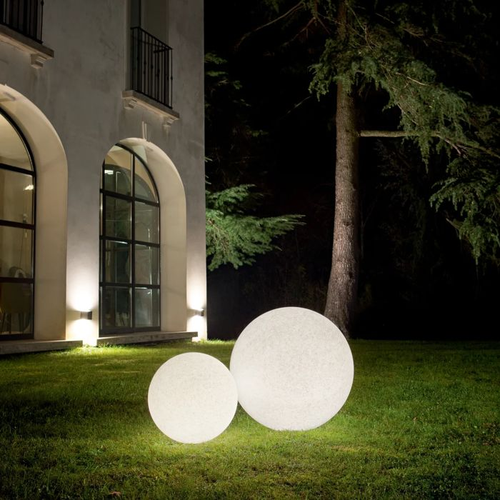

Specification
Dimensions | Ø 300 × H 300 mm
Lamp holder / power | E27 max 1 × 60W
IP rating | IP44 (outdoor rated)
Bulb included | No, sold separately
Dimming | Non-dimmable
Insulation class | II
Operating temperature | -20° ~ +40 °C
Warranty | 5 years
Net weight | 1.21 kg
EAN | 8021696214009
Product code | 214009

UK retail price: £127.00 ex VAT · £152.40 inc VAT
Trade, project and quantity pricing on request. Delivery and lead time confirmed at order.
Specification from the Ideal Lux technical sheet rev. 21-07-2026, checked 2026-10-01. Manufacturer data may change; confirm before ordering. Images © Ideal Lux.

