 | SPECIFICATION SHEET  Approved Ideal Lux dealer

IDEAL LUX · DUBAI COLLECTION · CHANDELIERS · INDOOR
Dubai SP10
Metal frame with chrome or brass finish. Decorative elements composed of transparent cut crystals pearls, octagons and prisms.
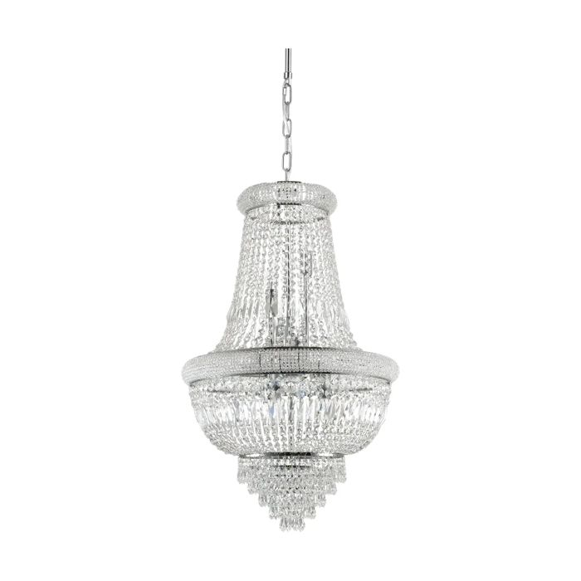 | 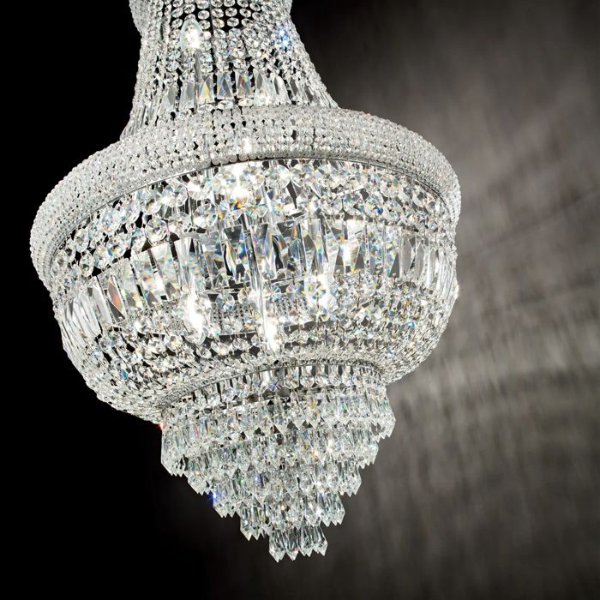

Specification
Dimensions | Ø 520 × H min 1080 / max 1900 mm
Lamp holder / power | E14 max 10 × 28W
IP rating | IP20 (indoor)
Bulb included | No, sold separately
Recommended bulb | 101224 E14 Oliva 4W 3000K Cri80 Trasp
Dimming | Non-dimmable
Insulation class | I
Operating temperature | 0° ~ +40 °C
Warranty | 5 years
Net weight | 9.17 kg
EAN | 8021696215969
Product code | 215969

UK retail price: £1,050.00 ex VAT · £1,260.00 inc VAT
Trade, project and quantity pricing on request. Delivery and lead time confirmed at order.
Specification from the Ideal Lux technical sheet rev. 23-07-2026, checked 2026-10-01. Manufacturer data may change; confirm before ordering. Images © Ideal Lux.

