 | SPECIFICATION SHEET  Approved Ideal Lux dealer

IDEAL LUX · GUN COLLECTION · OUTDOOR LIGHTING
Gun PL1
Aluminum body with brushed natural finish or with varnish or various finishes. Pyrex glass diffuser.
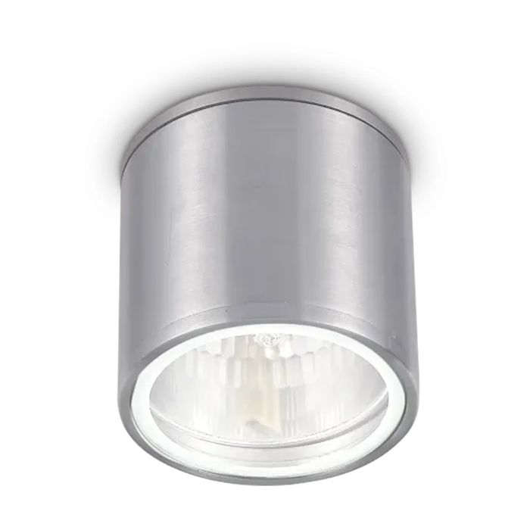 | 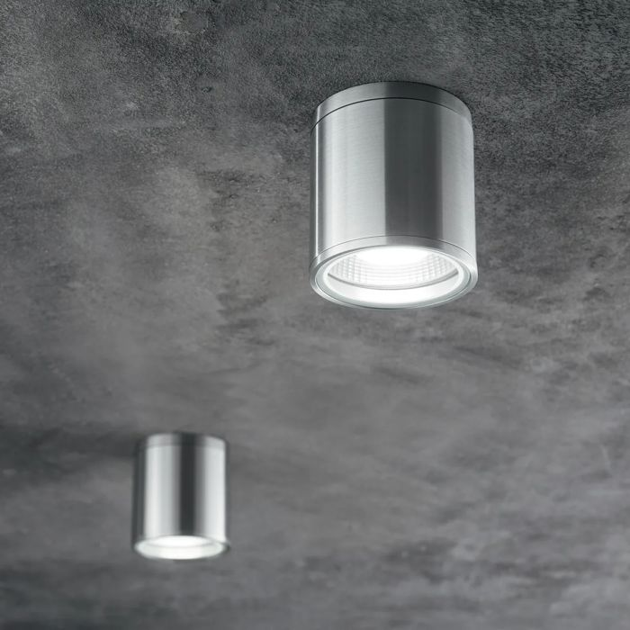

Specification
Dimensions | Ø 110 × H 115 mm
Lamp holder / power | GU10 max 1 × 28W
IP rating | IP55 (outdoor rated)
Bulb included | No, sold separately
Recommended bulb | 253497 Gu10 05W 430Lm 4000K Cri90
Dimming | Non-dimmable
Insulation class | I
Warranty | 5 years
Net weight | 0.49 kg
EAN | 8021696092324
Product code | 092324

UK retail price: £54.00 ex VAT · £64.80 inc VAT
Trade, project and quantity pricing on request. Delivery and lead time confirmed at order.
Specification from the Ideal Lux technical sheet rev. 21-07-2026, checked 2026-10-01. Manufacturer data may change; confirm before ordering. Images © Ideal Lux.

