 | SPECIFICATION SHEET  Approved Ideal Lux dealer

IDEAL LUX · NEGRESCO COLLECTION · CHANDELIERS · INDOOR
Negresco SP10
Metal frame with chrome or golden finish. Golden version with blown and gilded inside glass arms. Main structure composed of cut crystal blocks. Clear glass and cut crystal decorative elements.
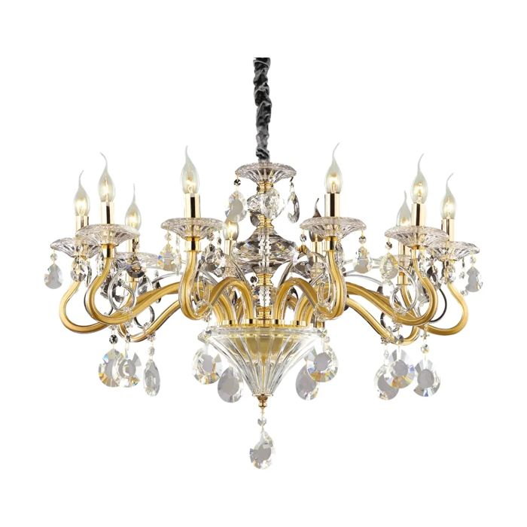 | 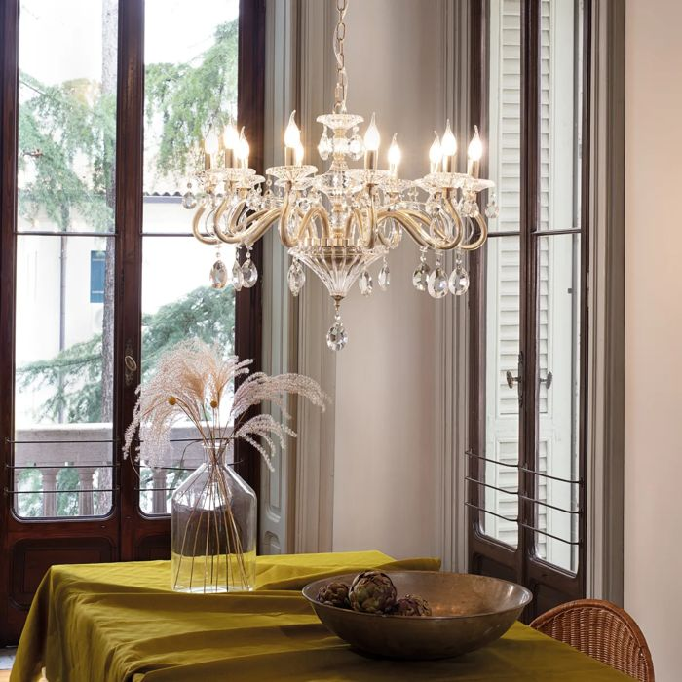

Specification
Dimensions | Ø 850 × H min 850 / max 1100 mm
Lamp holder / power | E14 max 10 × 28W
IP rating | IP20 (indoor)
Bulb included | No, sold separately
Dimming | Non-dimmable
Insulation class | I
Operating temperature | 0° ~ +40 °C
Warranty | 5 years
Net weight | 14.4 kg
EAN | 8021696087771
Product code | 087771

UK retail price: £1,000.00 ex VAT · £1,200.00 inc VAT
Trade, project and quantity pricing on request. Delivery and lead time confirmed at order.
Specification from the Ideal Lux technical sheet rev. 21-07-2026, checked 2026-10-01. Manufacturer data may change; confirm before ordering. Images © Ideal Lux.

