 | SPECIFICATION SHEET  Approved Ideal Lux dealer

IDEAL LUX · ONION COLLECTION · PENDANTS · INDOOR
Onion SP1 D23
Metal frame finished with brown varnish with metallic effect. Power cable coated with fabric.
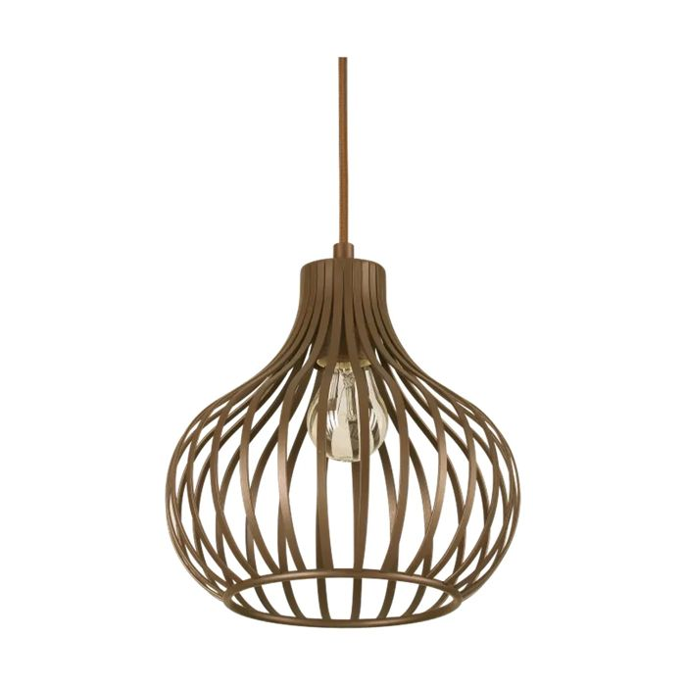 | 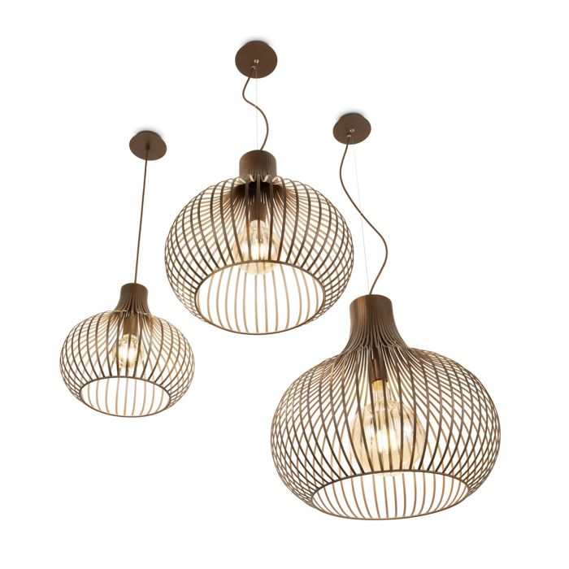

Specification
Dimensions | Ø 235 × H min 480 / max 2230 mm
Lamp holder / power | E27 max 1 × 60W
IP rating | IP20 (indoor)
Bulb included | No, sold separately
Dimming | Non-dimmable
Insulation class | II
Operating temperature | 0° ~ +40 °C
Warranty | 5 years
Net weight | 1.26 kg
EAN | 8021696205281
Product code | 205281

UK retail price: £75.00 ex VAT · £90.00 inc VAT
Trade, project and quantity pricing on request. Delivery and lead time confirmed at order.
Specification from the Ideal Lux technical sheet rev. 21-07-2026, checked 2026-10-01. Manufacturer data may change; confirm before ordering. Images © Ideal Lux.

