 | SPECIFICATION SHEET  Approved Ideal Lux dealer

IDEAL LUX · PAGE COLLECTION · WALL LIGHTS · INDOOR
Page AP Round
White or black powder coated aluminum body. Adjustable diffuser with lens and jointed chrome metal piece.
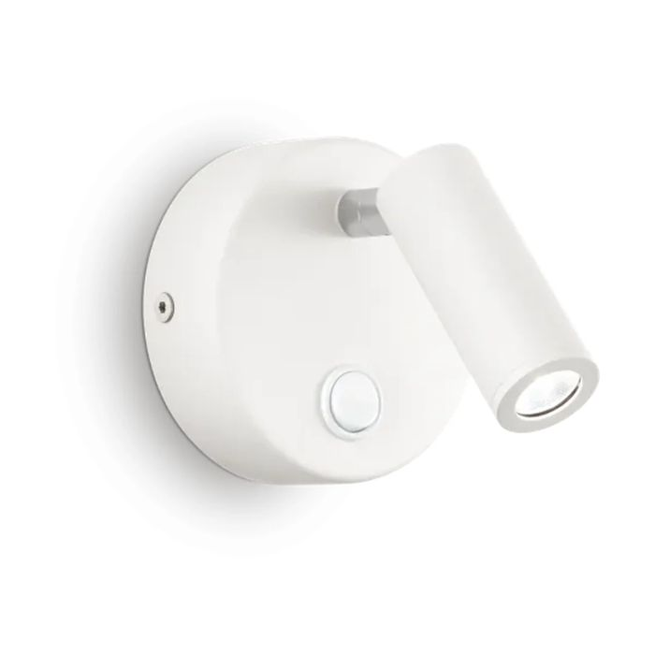 | 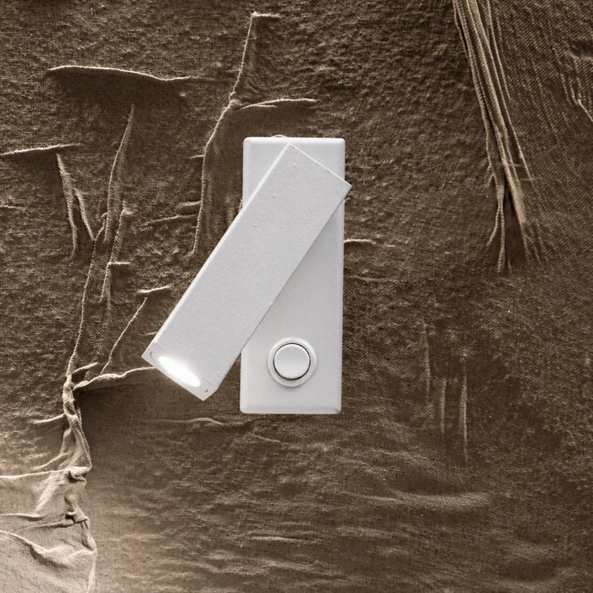

Specification
Dimensions | Ø 90 × D 130 mm (L length, H height, D depth)
Light source | LED 3W
LED lifetime | 30000 hours
Colour temperature | 3000 K
Light output (LED source) | 240 lumen
IP rating | IP20 (indoor)
Bulb included | Integrated LED
Colour rendering (CRI) | > 90
Light output (from fitting) | 180 lm
Dimming | Non-dimmable, On-Off
Insulation class | I
Operating temperature | 0° ~ +40 °C
Warranty | 5 years
Net weight | 0.32 kg
EAN | 8021696142586
Product code | 142586

UK retail price: £85.00 ex VAT · £102.00 inc VAT
Trade, project and quantity pricing on request. Delivery and lead time confirmed at order.
Specification from the Ideal Lux technical sheet rev. 21-07-2026, checked 2026-10-01. Manufacturer data may change; confirm before ordering. Images © Ideal Lux.

