 | SPECIFICATION SHEET  Approved Ideal Lux dealer

IDEAL LUX · SHELL COLLECTION · CEILING LIGHTS · INDOOR
Shell PL3
Plate-worked glass diffuser with grit decoration inside. Glass holder with metal detail. Available versions: clear glass with chrome detail or amber glass with gold detail.
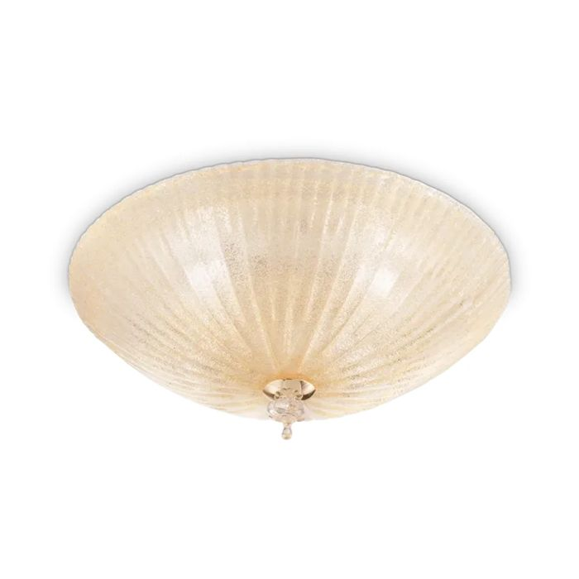 | 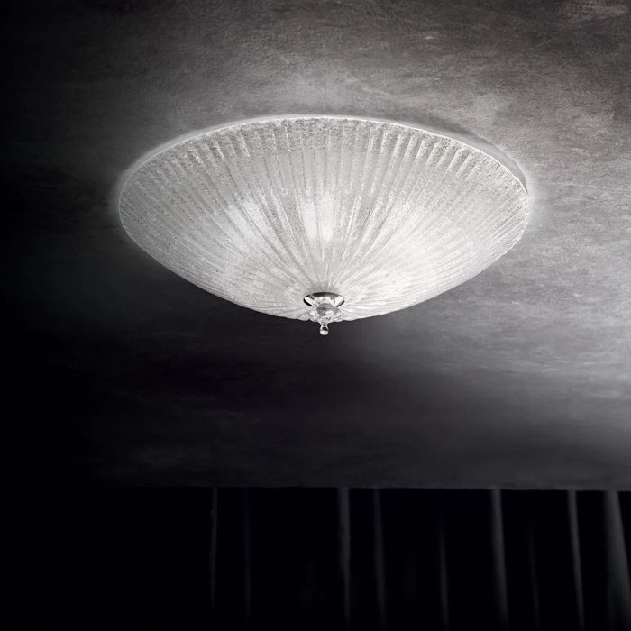

Specification
Dimensions | Ø 400 × H 120 mm
Lamp holder / power | E27 max 3 × 60W
IP rating | IP20 (indoor)
Bulb included | No, sold separately
Recommended bulb | 101279 E27 Sfera 4W 3000K Cri80 Trasp
Dimming | Non-dimmable
Insulation class | I
Operating temperature | 0° ~ +40 °C
Warranty | 5 years
Net weight | 3.64 kg
EAN | 8021696140179
Product code | 140179

UK retail price: £160.00 ex VAT · £192.00 inc VAT
Trade, project and quantity pricing on request. Delivery and lead time confirmed at order.
Specification from the Ideal Lux technical sheet rev. 21-07-2026, checked 2026-10-01. Manufacturer data may change; confirm before ordering. Images © Ideal Lux.

